LINUX COMMAND-3

1. How to Run two or more cammand?
Using ;

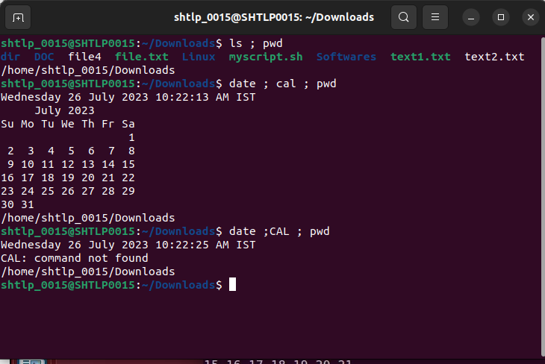
.
Using &&
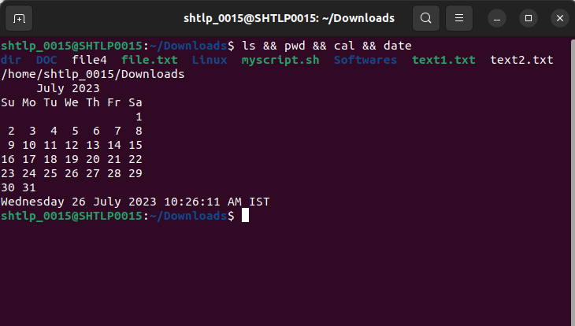

Using ||
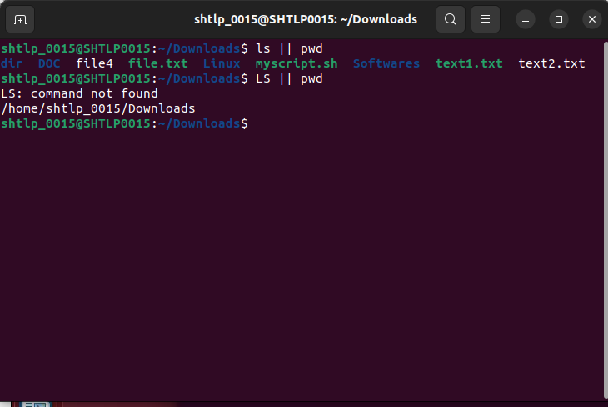
.

2. Apt – get command to install software
(Package Management ) : A package management tool used for installing .updating and removing software packages in Debian-based system.
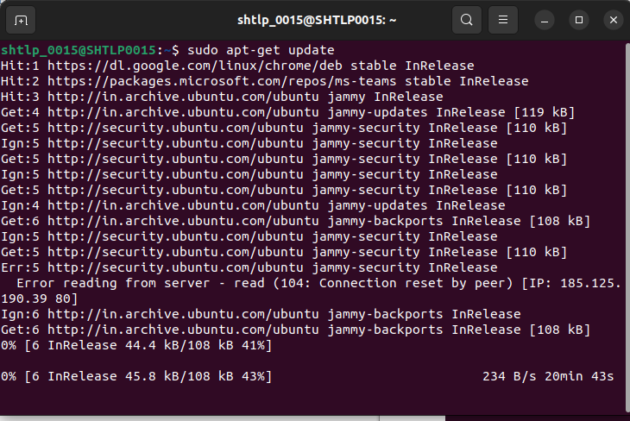
3. ifconfig command: it is used to change and view network interface on system
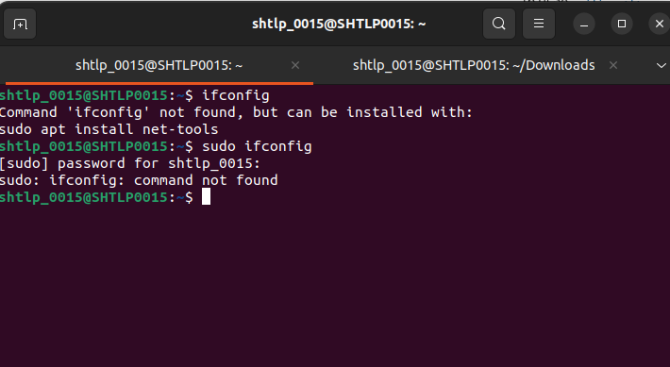
4. tar command : it is used to create, maintain, modify and extract files which are in a archieved in a tar format
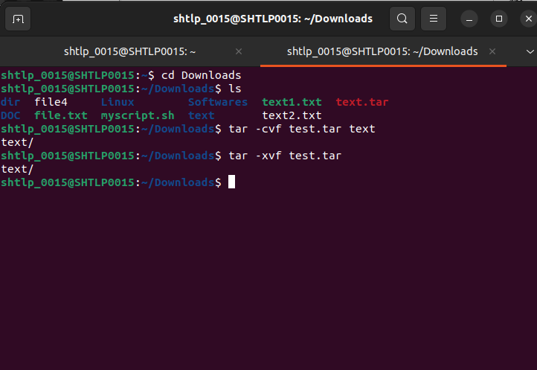
.

5.grep command: The grep filter searches a file for a particular pattern of characters, and displays all lines that contain that pattern.
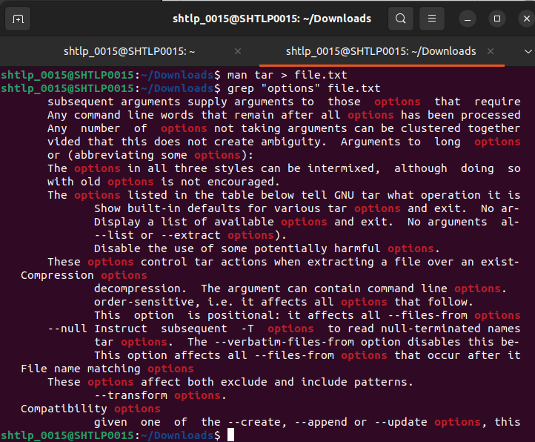
.
6. The netstat command:generates displays that show network status and protocol statistics.
